|  |  |  |  |
| --- | --- | --- | --- |
| Nice Côte d’Azur Airport | | |  |
| NCE/LFMN | |  |  |
|  |  |  |  |
| Summer 2023 - Start Of Season Report  Report data extraction date: 30 March 2023 | | |  |
|  |  |  |  |
|  |  |  |  |
|  | |  |  |

Table of contents

Evolution of allocated slots at the Start Of Season (SOS) 2

Total slots by operator – TOP15 2

Slots distribution per alliance 4

Size of aircraft 5

Allocated slots by destination 6

Geographical distribution of allocated slots 8

Slots distribution by service type 8

NCE S23 - Airport Coordination Parameters 9

Graphics: Initial demand 10

Graphics: SOS Allocated slots 12

Slots allocation by operator 14

*The contents of this report may not be reproduced without the written consent of COHOR.*

# Evolution of allocated slots at the Start Of Season (SOS)

**Summer 2022 (31 weeks): 79 595 Allocated Slots**

**Summer 2023 (31 weeks): 82 759 Allocated Slots**

**Allocated slots at SOS decreased by +3,98% from S22 to S23 (on average per week).**

**Slots Allocated OK S23:** 99,28%

# Total slots by operator – TOP15



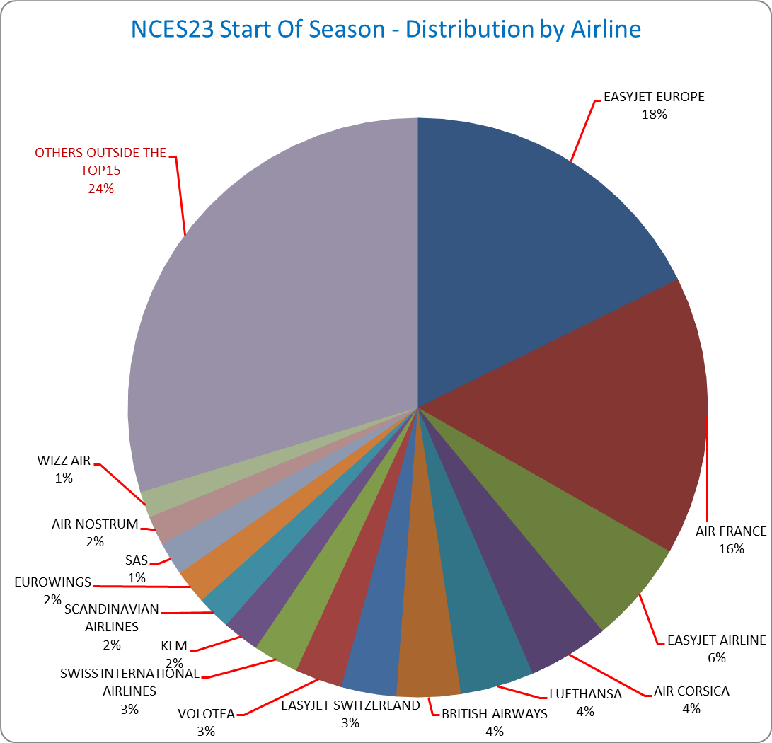

Slots distribution per alliance

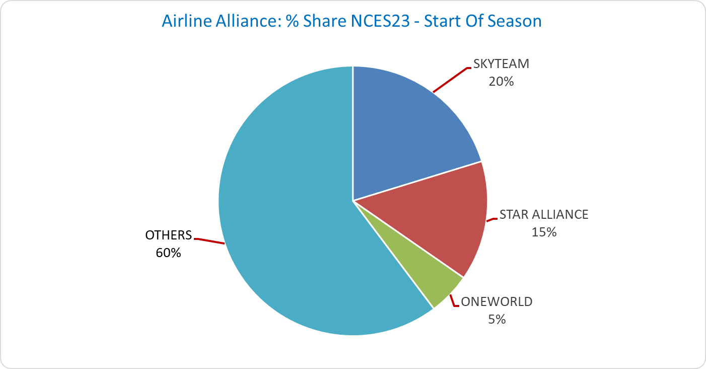



# Size of aircraft



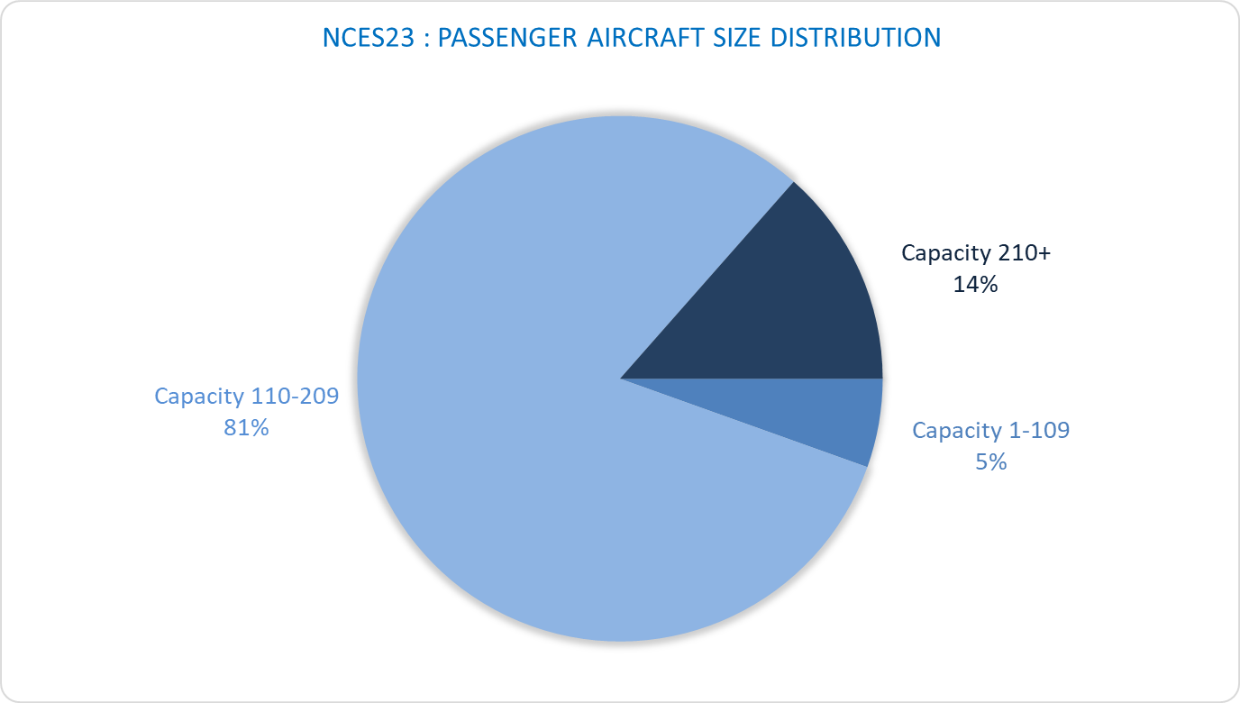

# Allocated slots by destination

(NCES23 vs NCES22)

# Geographical distribution of allocated slots

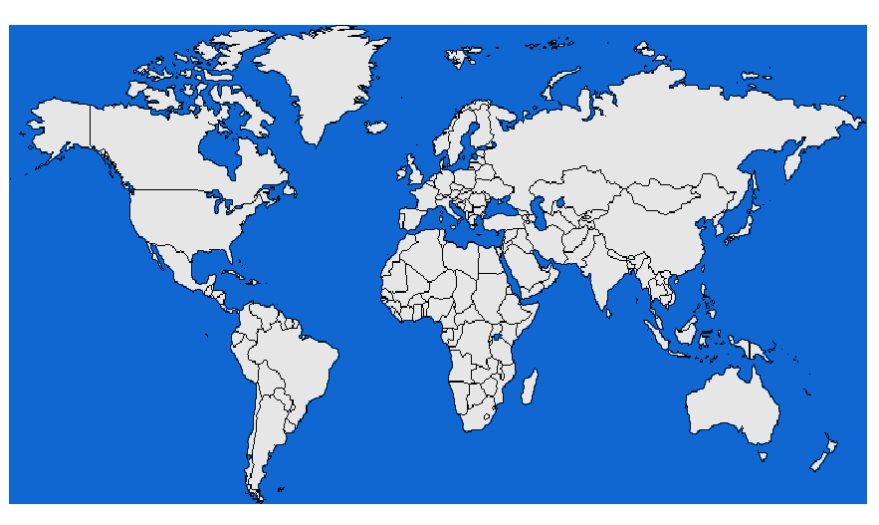

Central Asia 0,01%

South Ame 0,01%

Central Ame 0,00%

Africa 3,64%

Middle East 1,77%

South Eur 13,51%

North Eur 28,34%

France 33,30%

North Ame 1,99%

South East Asia 0,01%

East Eur 17,42%

# Slots distribution by service type



# NCE S23 - Airport Coordination Parameters

**Runway scheduling limits:**

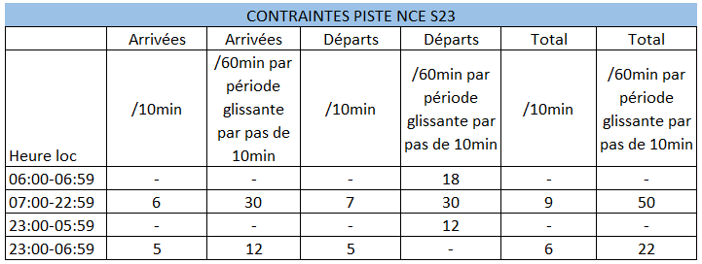

**Terminal constraints:** None

**Parking constraints:** For general and business aviation, turnrounds over 4 hours are submitted to stand allocation.

# Graphics: Initial demand

NCES23 R10 Arrival

NCES23 R10 Departure

NCES23 R10 Mixed

Graphics: SOS Allocated slots

NCES23 R10 Arrival

NCES23 R10 Departure

NCES23 R10 Mixed

# Slots allocation by operator

|  |  |
| --- | --- |
| Airline | Total Slot |
| AEGEAN AIRLINES | 292 |
| AER LINGUS | 478 |
| AEROITALIA SRL | 4 |
| AIR ALGERIE | 480 |
| AIR ARABIA MAROC | 46 |
| AIR BALTIC | 604 |
| AIR CANADA | 188 |
| AIR CORSICA | 3724 |
| AIR FRANCE | 12890 |
| AIR MALTA | 124 |
| AIR NOSTRUM | 1340 |
| AIR TRANSAT | 136 |
| ALBA STAR | 8 |
| ALPAVIA | 4 |
| ARKIA ISRAELI AIRLINES | 64 |
| ASL AIRLINES FRANCE | 10 |
| AUSTRIAN AIRLINES | 866 |
| BA Cityflyer | 736 |
| BA EUROFLYER LIMITED | 728 |
| BRITISH AIRWAYS | 2947 |
| Brussels Airlines | 994 |
| CELESTE | 154 |
| CODE ASSISTANT AVIAPARTNER | 394 |
| CONDOR | 368 |
| DC AVIATION G-OPS | 510 |
| DELTA AIR LINES | 716 |
| DREAMJET | 186 |
| EASTERN AIRWAYS LIMITED | 8 |
| EASYJET AIRLINE | 4756 |
| EASYJET EUROPE | 14642 |
| EASYJET SWITZERLAND | 2542 |
| EL AL | 278 |
| EMIRATES | 434 |
| ENTER AIR | 12 |
| EUROWINGS | 1580 |
| FEDEX EXPRESS | 310 |
| FINNAIR | 350 |
| FLY ONE | 120 |
| GULF AIR | 70 |
| IBERIA | 430 |
| ICELANDAIR | 52 |
| ITA - Italia Trasporto Aereo | 1158 |
| JET2.COM | 384 |
| JETTIME | 2 |
| KLM | 1704 |
| KUWAIT AIRWAYS | 70 |
| LOT POLISH AIRLINES | 482 |
| LUFTHANSA | 3402 |
| LUXAIR | 620 |
| MIDDLE EAST AIRLINES | 80 |
| NETJETS TRANSPORTES AEREOS S.A. | 480 |
| NOUVELAIR TUNISIE | 506 |
| Norwegian Air Shuttle AOC ASA | 954 |
| Norwegian Air Sweden AOC AB | 1560 |
| QATAR AIRWAYS | 206 |
| REGOURD AVIATION dba Amelia | 20 |
| ROYAL AIR MAROC | 286 |
| RYANAIR LTD | 770 |
| RYANAIR UK | 62 |
| SAUDI ARABIAN AIRLINES | 116 |
| SCANDINAVIAN AIRLINES | 1581 |
| SIGNATURE FLIGHT SUPPORT | 810 |
| SWISS INTERNATIONAL AIRLINES | 2103 |
| Smartwings, a.s. | 116 |
| TAP PORTUGAL | 842 |
| TAROM | 100 |
| THALAIR | 4 |
| THY TURKISH AIRLINES | 868 |
| TRADE AIR | 2 |
| TRANSAVIA AIRLINES | 824 |
| TRANSAVIA FRANCE | 504 |
| TUI FLY NEDERLAND | 2 |
| TUNISAIR | 1112 |
| UKRAINE INTL AIRLINES | 172 |
| UNITED AIRLINES | 290 |
| VOLOTEA | 2182 |
| VUELING AIRLINES | 978 |
| WIDEROES FLYVELSKAP | 100 |
| WIZZ AIR | 1206 |
| WIZZ AIR MALTA | 1120 |
| WIZZ AIR UK | 406 |