Lyon St Exupéry Airport
LYS/LFLL
Winter 2017 - Start Of Season Report

Report data extraction date: 02 November 2017

Table of contents

Evolution of allocated slots at the Start Of Season (SOS) 2
Slots distribution per alliance 4
Size of aircraft 5
Allocated slots by destination 6
Geographical distribution of allocated slots 8
Slots distribution by service type 8
LYSW17 - Airport Coordination Parameters 9
Graphics: Initial demand 10
Graphics: SOS Allocated slots 12
Slots allocation by operator 14

The contents of this report may not be reproduced without the written consent of COHOR.

Evolution of allocated slots at the Start Of Season (SOS)

Winter 2016 (21 weeks): 41 586 Allocated Slots

Winter 2017 (21 weeks): 41 913 Allocated Slots

Allocated slots at SOS increased by 0,79% from W16 to W17 (on average per week).

Slots Allocated OK W17: 99,94%

Total slots by operator – TOP15

Airline | W16 | %SHARE W16 | W17 | %SHARE W17 | %CHANGE (on average per week)
HOP | 14366 | 34,55% | 14132 | 33,72% | -1,63%
EASYJET AIRLINE | 6070 | 14,60% | 6337 | 15,12% | 4,40%
AIR FRANCE | 2316 | 5,57% | 2312 | 5,52% | -0,17%
LUFTHANSA | 2146 | 5,16% | 2152 | 5,13% | 0,28%
AIR ALGERIE | 1300 | 3,13% | 1384 | 3,30% | 6,46%
TRANSAVIA FRANCE | 784 | 1,89% | 1043 | 2,49% | 33,04%
TWIN-JET | 346 | 0,83% | 1016 | 2,42% | 193,64%
KLM | 864 | 2,08% | 864 | 2,06% | 0,00%
BRITISH AIRWAYS | 856 | 2,06% | 832 | 1,99% | -2,80%
TAP PORTUGAL | 742 | 1,78% | 748 | 1,78% | 0,81%
SN BRUSSELS AIRLINES | 730 | 1,76% | 732 | 1,75% | 0,27%
EUROWINGS | 452 | 1,09% | 700 | 1,67% | 54,87%
AIGLE AZUR TRANSPORTS AERIENS | 769 | 1,85% | 662 | 1,58% | -13,91%
TUNISAIR | 618 | 1,49% | 630 | 1,50% | 1,94%
AIR NOSTRUM | 547 | 1,32% | 547 | 1,31% | 0,00%
OTHERS | 8 680 | 20,87% | 7 822 | 18,66% | -9,88%
GRAND TOTAL | 41 586 | 100,00% | 41 913 | 100,00% | 0,79%
Part of AF/KL Group* | 18 330 | 44,08% | 18 359 | 43,80% | 0,16%

* AIRFRANCE - HOP - KLM - TRANSAVIAFRANCE - TRANSAVIAHOLLANDE

Slots distribution per alliance

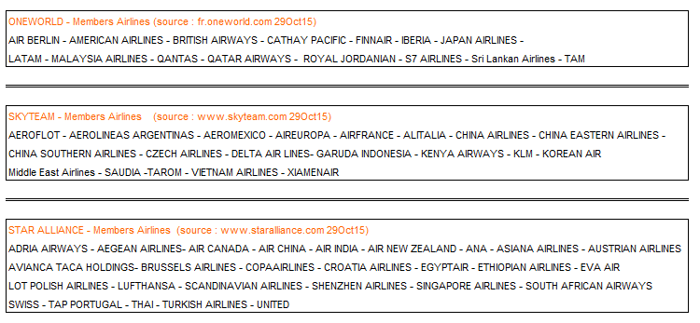

Size of aircraft

 | W16 | W17 | Evolution
Average Size of Aircraft (Seats) | 123 | 126 | 2,8%
Total Passenger Seat Offer | 4 855 462 | 5 033 481 | 3,7%

Allocated slots by destination

(LYSW17 vs LYSW16)

Geographical distribution of allocated slots

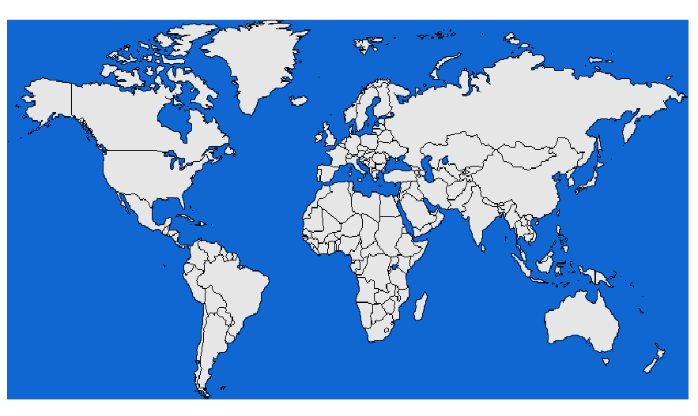
Middle East 0,80%
South Eur 17,22%
France 41,50%
East Eur 15,03%
Central Asia 0,005%
North Ame 0,35%
North Eur 14,14%
Central Ame 0,05%
Africa 10,91%

Slots distribution by service type

Group Services for All Destinations |  | W17 | W16
Regular Services |  | 94,36% | 94,24%
Freight Services |  | 4,45% | 4,58%
Charter Services |  | 0,90% | 0,92%
Technical Services |  | 0,26% | 0,22%
Others |  | 0,03% | 0,04%

LYSW17 - Airport Coordination Parameters

Runway scheduling limits:

From summer S14, following the increase of capacity allowed by runway works on Lyon airport, the order of October 4th, 2013 modifies the runway constraints as follows:

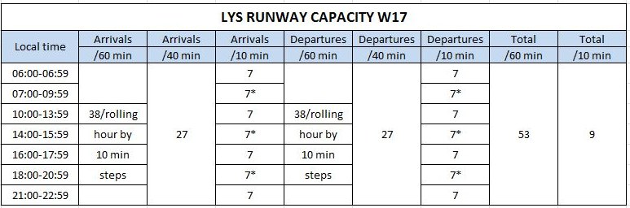

7* means that during a rolling time period, maximum 8 movements can be accepted during two periods of 10 minutes, 7 movements during the subsequent four periods of 10 minutes, in compliance with the corresponding runway constraints.

Terminal constraints: None

Graphics: Initial demand

LYSW17 R10 Arrival
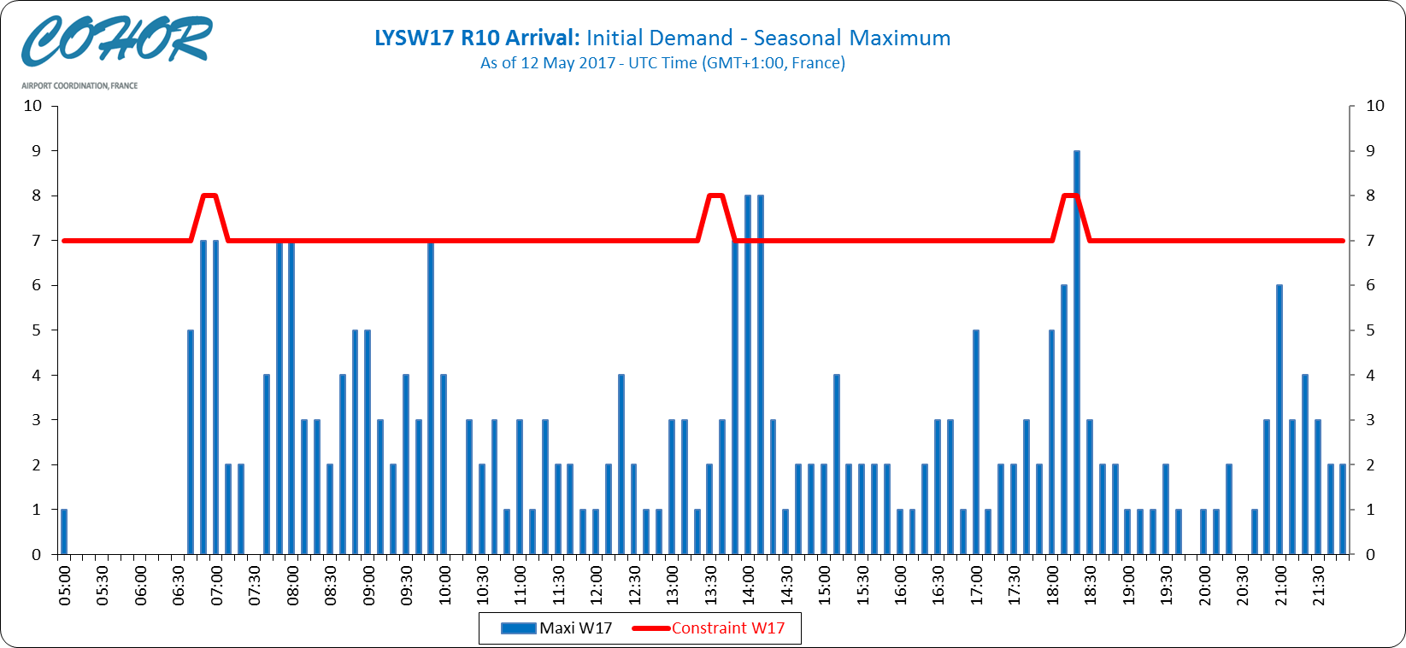

LYSW17 R10 Departure
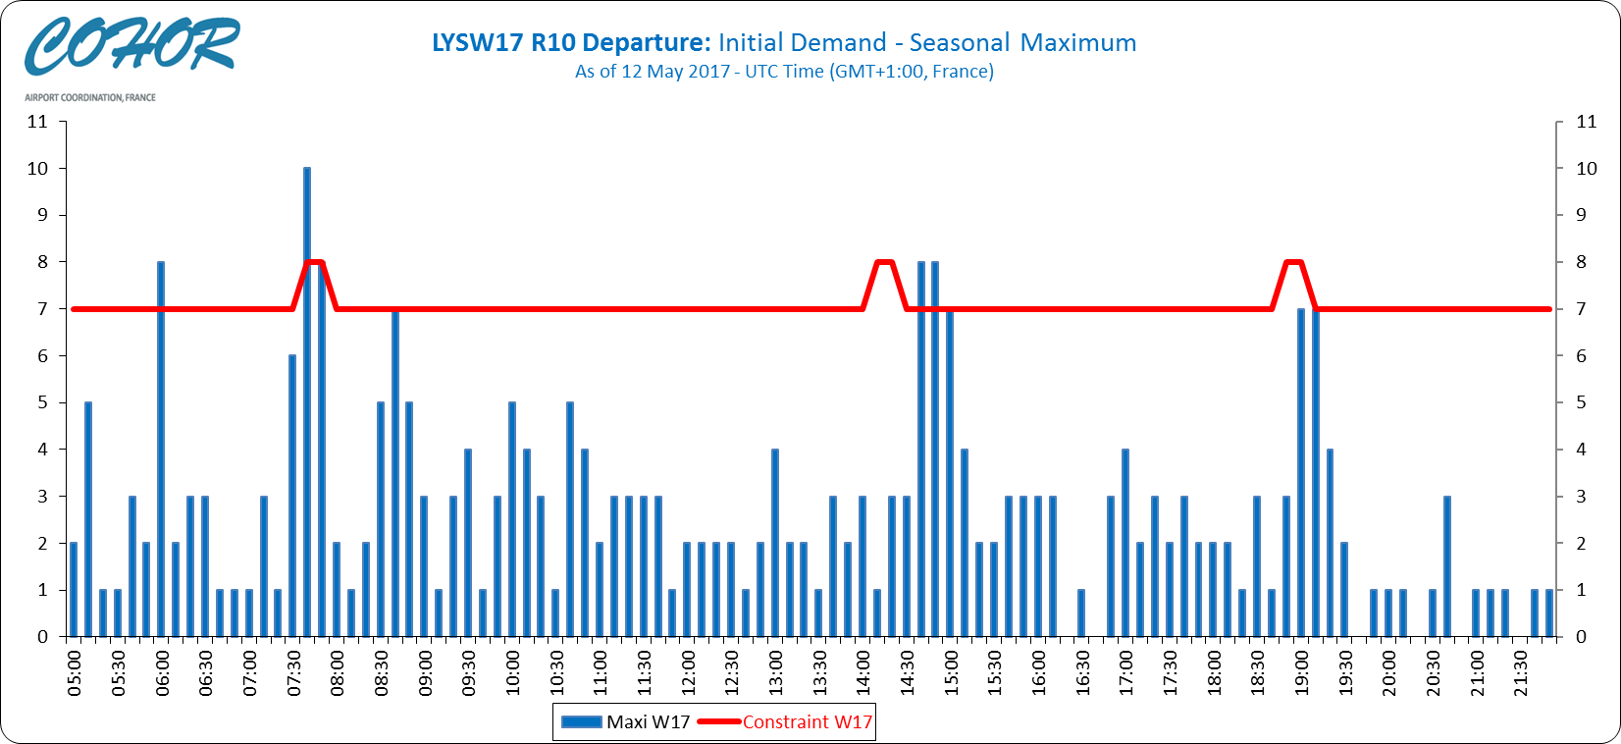

LYSW17 R10 Mixed
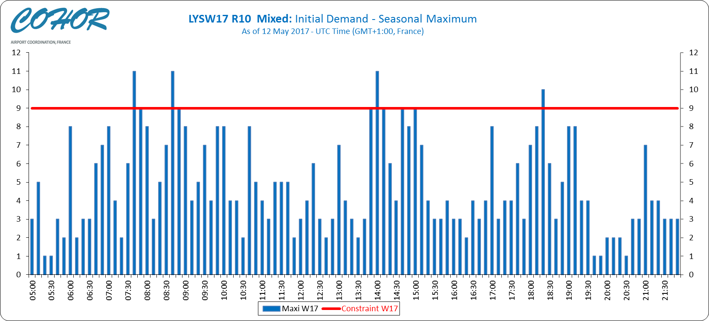

Graphics: SOS Allocated slots

LYSW17 R10 Arrival
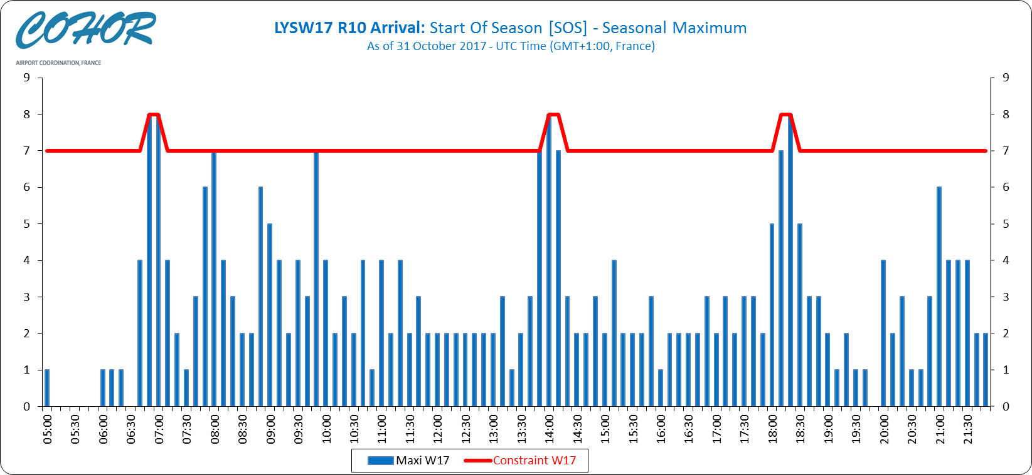

LYSW17 R10 Departure
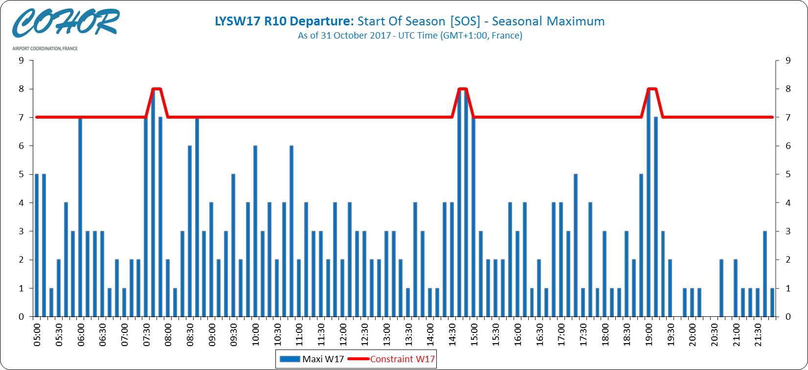

LYSW17 R10 Mixed
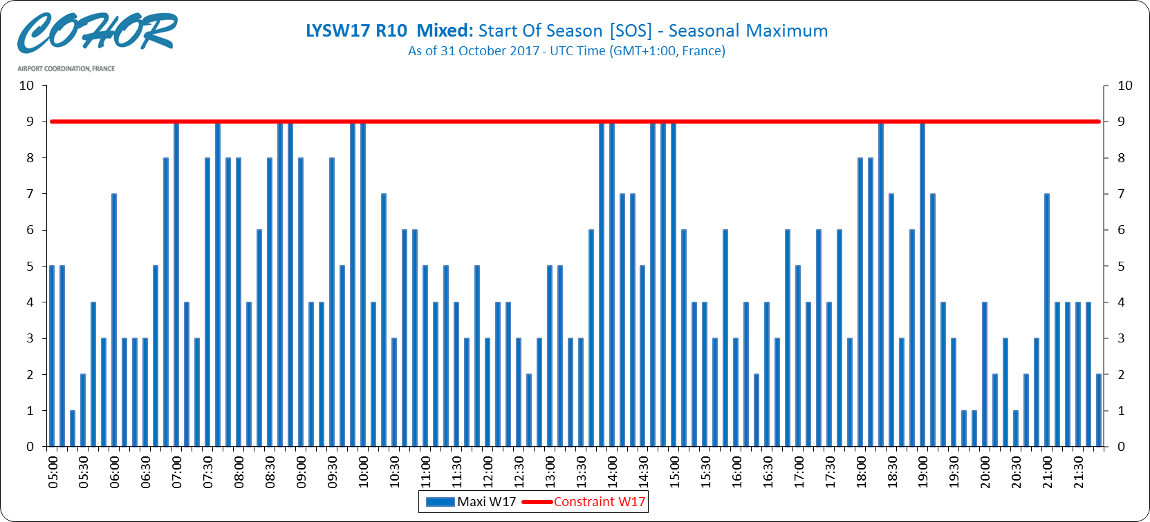

Slots allocation by operator

Airline | Total Slot
AEGEAN AIRLINES | 44
AER LINGUS | 320
AEROFLOT RUSSIAN AIRLINES | 294
AIGLE AZUR TRANSPORTS AERIENS | 662
AIR ALGERIE | 1384
AIR ARABIA MAROC | 258
AIR CANADA | 140
AIR CORSICA | 256
AIR EXPLORE | 4
AIR FRANCE | 2312
AIR MALTA | 6
AIR NOSTRUM | 547
AIR SLOVAKIA | 2
AIR TRANSAT | 4
AirHorizont | 4
ALITALIA | 2
APG AIRLINES | 1
ASL Airlines Belgium | 420
ASL AIRLINES FRANCE | 240
AUSTRIAN AIRLINES | 468
BLUE AIR-AIRLINE | 84
BRITISH AIRWAYS | 832
CARPATAIR | 8
CHALAIR | 388
COBALT AIR | 4
CODE ASSISTANT AVIAPARTNER | 7
CORENDON AIRLINES | 24
EASYJET AIRLINE | 6337
EASYJET SWITZERLAND | 1
EMIRATES | 210
ENTER AIR | 44
EUROPEAN AIR TRANSPORT | 374
EUROWINGS | 700
FEDEX EXPRESS | 332
FLYBE | 534
FLYLAL | 22
FREE BIRD AIRLINES | 16
GERMANIA FLUGGESELLSCHAFT | 4
HOP | 14132
IBERIA EXPRESS | 168
ISRAIR AIRLINES | 16
JETAIRFLY | 127
JET2.COM | 74
KLM | 864
LUFTHANSA | 2152
MALETH-AERO | 2
MONARCH AIRLINES | 30
Norvegian Air International Ltd | 30
NOUVELAIR TUNISIE | 170
PEGASUS AIRLINES | 278
PICHARD EXE HANDLING | 2
ROYAL AIR MAROC | 446
SIAVIA | 6
SIBERIAN AIRLINES | 26
Smartlynx Airlines Estonia | 16
SN BRUSSELS AIRLINES | 732
SPACE AERO HANDLING | 5
STAR AIR | 416
Stobart Air (ex REA) | 88
TAP PORTUGAL | 748
THOMSONFLY | 4
THY TURKISH AIRLINES | 504
TITAN AIRWAYS | 4
TRADE AIR | 4
TRANSAVIA AIRLINES | 8
TRANSAVIA FRANCE | 1043
TRAVEL SERVICE AIRLINES | 163
TUNISAIR | 630
TWIN-JET | 1016
VUELING AIRLINES | 510
WIZZ AIR | 84
XL AIRWAYS FRANCE | 126

